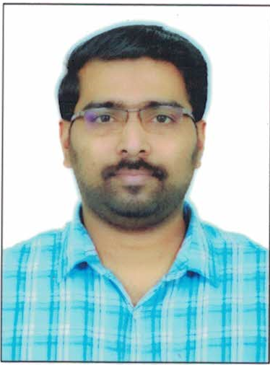

Photo

STAFF PROFILE

- Personal file .

Name of the Teaching Staff | LIJO JOHNY
Designation | Assistant Professor
Department | Dept. of Economics
Date of Birth | 15/10/1983 |  | Date of Joining the Institution |  |  |  | 04/01/2012
Educational Qualification | UG – BA Economics |  | PG – MA Economics |  |  |  |  |  | PhD –
Area of Interest | Micro Finance, Banking
Total Experience | Teaching 10 Year 10 Months |  | Industry – |  |  |  |  |  | Research –
No. of Papers Published in Journals | National - |  | International -
No. of Papers Presented in Conferences | National - 1 |  | International -
No. of Seminars / Workshops Attended | National- 14 |  | International-
Programs Conducted | Conference  National :  International : |  | Seminar  National :  International : |  |  |  |  | Workshop -
Trainings attended | Orientation | Academic Staff College, University of Calicut  28days (24/02/2016 to 22/03/2016)
Trainings attended | Refresher | UGC HRDC, University of Calicut  21 days (20/05/2016 to 09/06/2016
Trainings attended | FDP | One week FDP on 'The Dynamics of Research: Prospects, Reflections and Best Practices' organized under UGC – Scheme for Trans-Disciplinary Research for India's Developing Economy (UGC-STRIDE), Mahatma Gandhi University, Kerala, in association with IQAC, St. Xavier's College for Women, Aluva, from 1st to 7th July 2021.
Trainings attended | FDP | One Week FDP on “Digital Technologies for E_Learning” Organised by Department of PhysicsSNM College Maliankara, Ernakulam in academic collaboration with Kerala State Higher Education Council Form 5-8-2021 to 11-08-2021
Positions held at University Level | Board of Studies- |  |  | Curriculum Revision- |  | Subject Expert |  |  |  | Any Other-
PhD Guide? Give field & University | Field: |  | University :
No. of PhDs / Projects Guided | PhDs - |  | Projects at Masters Level:
Books Published / IPRs/ Patents
Professional Memberships | Member – Kerala Economic Association
Consultancy Activities
Awards
Grants fetched | Minor Projects- 1 (1.45 lakhs) |  |  |  | Major Projects
Interaction with Professional Institutions

Papers Presented in Conferences/Seminars
- Lijo Johny, “FDI in Multi Retail Sector in India- Is it Necessary” UGC Sponsored National seminar on ‘Foreign Direct Investment in Multi-Brand Retail Sector in India- Issues and Challenges Ahead’ at Mar Athanasius College Kothamangalam. 7 & 8 March 2013
Seminars / Workshops Attended
- UGC Sponsored National Seminar on “Public- Private Partnership: Policies, Practices & Perspectives” held at NEWMAN College Thodupuzha, 17-18 April, 2013
- UGC Sponsored Seminar on Music Organized by the Department of Student Services at SSV College Valayanchirangara, 28 September 2012
- UGC Sponsored National Seminar on “ Language Teaching Methodologies in Sanskrit” held at SSV College Valayanchirangara, 19-20 January 2012
- National Seminar on “Informal Sector in India: Lessons and Way Forward” held at St. Thomas College Thrissur, 14-15 November 2012
- Participated in One day Training programme organised by Kerala State Higher Education Council on Higher Education Scholarship Programmes held at School of Environmental Sciences , M G University , on 8th October 2013
- Attended One Day Training on ASAP Summer Skill Skool DOT conducted by Higher Education Department on 3rd March 2015
- Participated in UGC Sponsored National Seminar On “ Manthravadham: Folklore, History, Cultural Studies held at Sree Sankara Vidyapeetom College Valayanchirangara on 21st and 22nd July 2015.
- Participated in UGC Sponsored National Seminar On “ Role of corporate Social Responsibility On Modern Business Era” held at Sree Sankara Vidyapeetom College Valayanchirangara on 6th and 7th August 2015.
- Participated in UGC Sponsored National Seminar On “ Tourism and Sustainable Economic Development in India- Ecological Perspectives and Issues ” held at Newman College, Thodupuzha on 22nd and 23rd September 2015.
- Attended One day Training in connection with the online implementation of Kerala Private College Staff Provident Fund organised by the Department of Collegiate Education on 16/07/2015
- Participated in the Webinar on Social Responsibility of Institutions of Higher Learning organized by the UBA Cell of St Xavier’s College for Women,Aluva on 30th May 2020
- Participated in the National Webinar on Covid 19: Rural Economy and the Indian Policy response Organized by Department of Economics, Newman College Thodupuzha on 16-05-2020
- Participated Three day National webinar on “Impact of Covid 19: Effectiveness of Government Measures” organized by Department of Economics, SNM College, Maliankara, 25 to 27 May 2020
- Participated in The Natioanal Webinar on “Reverse Migration: Challenges and Opportunities in the context of Covid -19 “ organized by Department of Management Studies, VJCET, Vazhakula on 29 May 2020
Coordinator Principal

